Supplementary Figure S1
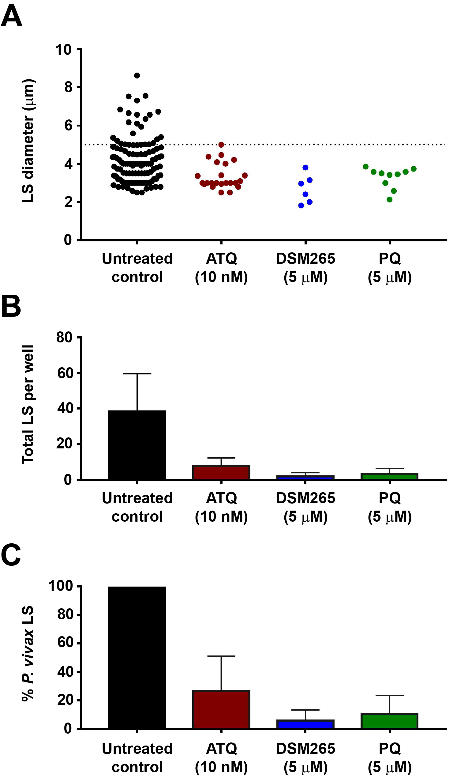
Fig. S1. P. vivax liver-stage parasites in imHC cultures. imHCs were grown in an eight-well plate at a density of 3 x 10⁵/well. Each well was infected with 2.5 x 10⁵ salivary gland P. vivax sporozoites. The infected cultures were exposed to 10 nM atovaquone (ATQ), 5 μM DSM265, 5 μM primaquine (PQ), or 0.1% DMSO control from day 1 to day 3 post-infection. Liver-stage (LS) parasites were harvested and visualized by immunofluorescence staining using anti-HSP70 antibody on day 4 post-infection. (A) Sizes and (B) numbers of remaining parasites in the cultures after treatment were measured. (C) The percent P. vivax liver-stages was determined by comparing the total number of drug-treated parasites to the total number of untreated control. Data are shown as means ± standard deviations of three replicated wells from one P. vivax isolate.

